Name : Tushar Pathak
Reg Num : 230905396
Roll Num : 6CSEB-B2

Week 9 : Form Processing using Django – Part II

AQ1)Create a website with two pages.
First page contains:
RadioButton with HP, Nokia, Samsung, Motorola, Apple as options.
CheckBox with Mobile and Laptop as items.
TextBox to enter quantity.
There is a button with text as "Produce Bill".
On Clicking Produce Bill button, item should be displayed with total amount on
another page.
Output :
Page One

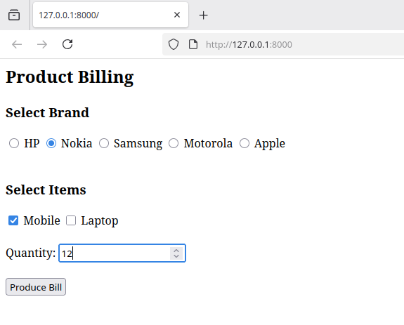

Output Page

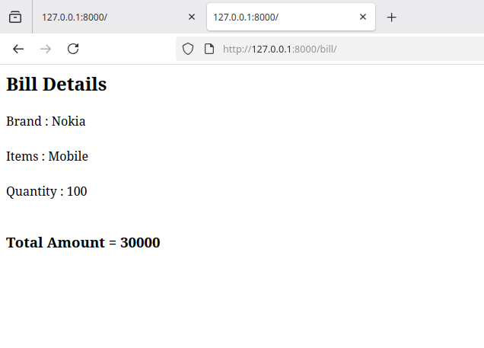

AQ2)Writeprogram to display the following feedback form. The different options for
the list box must be ASP-XML, DotNET, JavaPro and Unix,C,C++. When the Submit
Form button is clicked after entering the data, a message as seen in the last line of
the above figure must be displayed.
Output:

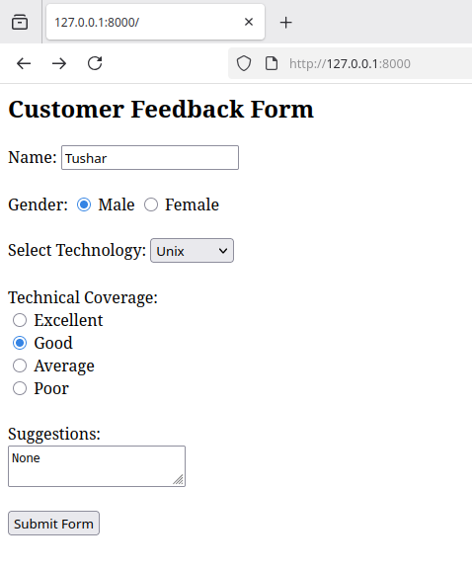
Feedback form
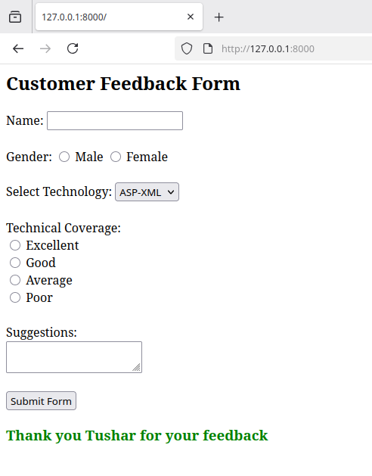
Output message

